Workshop Web Server
(TIF330805)

LAPORAN



ACARA 14

WIDYA ANITAR ROSYIDAH
NIM E41250352

TEKNIK INFORMATIKA KAB. NGANJUK
JURUSAN TEKNOLOGI INFORMASI
POLITEKNIK NEGERI JEMBER
TAHUN 2026

Acara 14 Security, Exception, Logging, PRG, dan Integrasi CRUD Lengkap

Prosedur Kerja
Studi Kasus
Aplikasi Sistem Informasi Akademik sudah dapat melakukan CRUD data
mahasiswa. Namun, aplikasi masih memiliki beberapa masalah:
• Input pengguna belum divalidasi dengan baik.
• Query database harus aman dari SQL Injection.
• Jika terjadi error database, aplikasi menampilkan error teknis kepada pengguna.
• Belum ada catatan (log) ketika terjadi error.
• Setelah form disubmit, ketika halaman di-refresh, data dapat terkirim kembali.
• Fitur CRUD belum terintegrasi secara lengkap dengan MySQL.
Untuk mengatasi masalah tersebut, aplikasi akan diperbaiki dengan menerapkan
Security, Exception Handling, Logging, PRG, dan CRUD lengkap.
CRUD Mahasiswa Aman dengan MySQL
Tujuan
Mahasiswa membuat aplikasi CRUD Data Mahasiswa yang terintegrasi dengan
MySQL serta menerapkan:
• Security
• Validasi input
• Prepared Statement
• Exception Handling
• Logging
• Session
• Flash Message
• PRG
• CRUD lengkap

Langkah Praktikum
- Hubungkan aplikasi dengan MySQL
Gunakan PDO untuk membuat koneksi database.
<?php

namespace App\Core;

use PDO;

class Database
{
private static ?self $instance = null;
private PDO $connection;

public function __construct(?PDO $connection = null)
{
if ($connection !== null) {
$this->connection = $connection;
return;
}

$config = require __DIR__ . '/../../config/database.php';
$dsn = sprintf(
'mysql:host=%s;dbname=%s;charset=%s',
$config['host'],
$config['dbname'],
$config['charset']
);

$this->connection = new PDO($dsn, $config['username'], $config['password'], [
PDO::ATTR_ERRMODE => PDO::ERRMODE_EXCEPTION,
PDO::ATTR_DEFAULT_FETCH_MODE => PDO::FETCH_ASSOC,
PDO::ATTR_EMULATE_PREPARES => false,
]);
}

public static function getInstance(): self
{
if (self::$instance === null) {
self::$instance = new self();
}

return self::$instance;
}

public function getConnection(): PDO
{
return $this->connection;
}
}

- Pastikan Repository menggunakan Prepared Statement
Implementasikan method:
<?php

namespace App\Models;

use App\Core\Database;

require_once __DIR__ . '/BaseModel.php';

class MahasiswaRepository extends BaseModel
{
public function __construct(Database $database)
{
parent::__construct($database);
}

public function all(string $search = '', int $limit = 10, int $offset = 0): array
{
$query = $this->db->prepare(
'SELECT mahasiswa.id, mahasiswa.nim, mahasiswa.nama, mahasiswa.email,
mahasiswa.prodi_id, prodi.nama AS prodi, mahasiswa.angkatan, mahasiswa.status
FROM mahasiswa
INNER JOIN prodi ON prodi.id = mahasiswa.prodi_id
WHERE mahasiswa.nim LIKE :search_nim OR mahasiswa.nama LIKE :search_nama
ORDER BY mahasiswa.id LIMIT :limit OFFSET :offset'
);
$query->bindValue(':search_nim', '%' . $search . '%');
$query->bindValue(':search_nama', '%' . $search . '%');
$query->bindValue(':limit', $limit, \PDO::PARAM_INT);
$query->bindValue(':offset', $offset, \PDO::PARAM_INT);
$query->execute();

return $query->fetchAll();
}

public function count(string $search): int
{
$query = $this->db->prepare(
'SELECT COUNT(*) FROM mahasiswa
WHERE nim LIKE :search_nim OR nama LIKE :search_nama'
);
$query->execute([
'search_nim' => '%' . $search . '%',
'search_nama' => '%' . $search . '%',
]);

return (int) $query->fetchColumn();
}

public function find(int $id): ?array
{
$query = $this->db->prepare(
'SELECT mahasiswa.id, mahasiswa.nim, mahasiswa.nama, mahasiswa.email,
mahasiswa.prodi_id, prodi.nama AS prodi, mahasiswa.angkatan, mahasiswa.status
FROM mahasiswa
INNER JOIN prodi ON prodi.id = mahasiswa.prodi_id
WHERE mahasiswa.id = :id'
);
$query->execute(['id' => $id]);
$mahasiswa = $query->fetch();

return $mahasiswa === false ? null : $mahasiswa;
}

public function create(Mahasiswa $mahasiswa): void
{
$query = $this->db->prepare(
'INSERT INTO mahasiswa (nim, nama, email, prodi_id, angkatan, status)
VALUES (:nim, :nama, :email, :prodi_id, :angkatan, :status)'
);
$query->execute([
'nim' => $mahasiswa->getNim(),
'nama' => $mahasiswa->getNama(),
'email' => $mahasiswa->getEmail(),
'prodi_id' => $mahasiswa->getProdiId(),
'angkatan' => $mahasiswa->getAngkatan(),
'status' => $mahasiswa->getStatus(),
]);
}

public function update(int $id, Mahasiswa $mahasiswa): void
{
$query = $this->db->prepare(
'UPDATE mahasiswa
SET nim = :nim, nama = :nama, email = :email, prodi_id = :prodi_id,
angkatan = :angkatan, status = :status
WHERE id = :id'
);
$query->execute([
'id' => $id,
'nim' => $mahasiswa->getNim(),
'nama' => $mahasiswa->getNama(),
'email' => $mahasiswa->getEmail(),
'prodi_id' => $mahasiswa->getProdiId(),
'angkatan' => $mahasiswa->getAngkatan(),
'status' => $mahasiswa->getStatus(),
]);
}

public function delete(int $id): void
{
$query = $this->db->prepare('DELETE FROM mahasiswa WHERE id = :id');
$query->execute(['id' => $id]);
}

public function existsByNim(string $nim, ?int $exceptId = null): bool
{
$sql = 'SELECT COUNT(*) FROM mahasiswa WHERE nim = :nim';
$params = ['nim' => $nim];
if ($exceptId !== null) {
$sql .= ' AND id <> :id';
$params['id'] = $exceptId;
}

$query = $this->db->prepare($sql);
$query->execute($params);

return (int) $query->fetchColumn() > 0;
}
}

- Buat MahasiswaService
Service bertugas melakukan:
• validasi NIM,
• validasi nama,
• validasi email,
• pengecekan NIM duplikat,
• memanggil Repository.
<?php

namespace App\Services;

use App\Models\Mahasiswa;
use App\Models\MahasiswaRepository;
use App\Models\ProdiRepository;
use InvalidArgumentException;

class MahasiswaService
{
public function __construct(
private MahasiswaRepository $mahasiswaRepository,
private ProdiRepository $prodiRepository
) {
}

/**
* @return array{success: bool, errors: array<int, string>, formData: array<string, mixed>}
*/
public function create(array $input): array
{
$result = $this->validate($input);
if (!$result['success']) {
return $result;
}

$this->mahasiswaRepository->create($result['mahasiswa']);

return [
'success' => true,
'errors' => [],
'formData' => $result['formData'],
];
}

/**
* @return array{success: bool, errors: array<int, string>, formData: array<string, mixed>}
*/
public function update(int $id, array $input): array
{
$result = $this->validate($input, $id);
if (!$result['success']) {
return $result;
}

$this->mahasiswaRepository->update($id, $result['mahasiswa']);

return [
'success' => true,
'errors' => [],
'formData' => $result['formData'],
];
}

/**
* @return array{success: bool, errors: array<int, string>, formData: array<string, mixed>, mahasiswa?: Mahasiswa}
*/
private function validate(array $input, ?int $exceptId = null): array
{
$formData = [
'nim' => $this->stringValue($input['nim'] ?? null),
'nama' => $this->stringValue($input['nama'] ?? null),
'email' => $this->stringValue($input['email'] ?? null),
'prodiId' => $this->integerValue($input['prodi_id'] ?? null),
'angkatan' => $this->integerValue($input['angkatan'] ?? null),
'status' => $this->stringValue($input['status'] ?? 'aktif'),
];

$mahasiswa = new Mahasiswa();
$errors = [];
$setters = [
'NIM' => static fn () => $mahasiswa->setNim($formData['nim']),
'Nama' => static fn () => $mahasiswa->setNama($formData['nama']),
'Email' => static fn () => $mahasiswa->setEmail($formData['email']),
'Program studi' => static fn () => $mahasiswa->setProdiId($formData['prodiId']),
'Angkatan' => static fn () => $mahasiswa->setAngkatan($formData['angkatan']),
'Status' => static fn () => $mahasiswa->setStatus($formData['status']),
];

foreach ($setters as $setter) {
try {
$setter();
} catch (InvalidArgumentException $exception) {
$errors[] = $exception->getMessage();
}
}

if (
$formData['prodiId'] > 0
&& !$this->prodiRepository->exists($formData['prodiId'])
) {
$errors[] = 'Pilih program studi yang tersedia.';
}

$nim = $formData['nim'];
if (
$nim !== ''
&& strlen($nim) <= 20
&& ctype_digit($nim)
&& $this->mahasiswaRepository->existsByNim($nim, $exceptId)
) {
$errors[] = 'NIM tersebut sudah terdaftar.';
}

if ($errors !== []) {
return [
'success' => false,
'errors' => $errors,
'formData' => $formData,
];
}

return [
'success' => true,
'errors' => [],
'formData' => $formData,
'mahasiswa' => $mahasiswa,
];
}

private function stringValue(mixed $value): string
{
return is_scalar($value) ? trim((string) $value) : '';
}

private function integerValue(mixed $value): int
{
if (!is_scalar($value)) {
return 0;
}

$integer = filter_var((string) $value, FILTER_VALIDATE_INT);

return $integer === false ? 0 : $integer;
}
}

- Terapkan Exception Handling
Gunakan try-catch pada proses CRUD yang berpotensi mengalami error.
public function create(): void
{
try {
$prodi = $this->prodiRepository->all();
$formData = [];
$isEditing = false;
$this->view('layouts/main', [
'title' => 'Tambah Mahasiswa | SI Akademik',
'content' => __DIR__ . '/../Views/mahasiswa/create.php',
'prodi' => $prodi,
'formData' => $formData,
'isEditing' => $isEditing,
]);
} catch (Throwable $exception) {
$this->showFailure($exception, 'Form mahasiswa gagal dimuat.');
}
}

- Buat Logging
Jika terjadi exception, simpan detail error ke: storage/logs/app.log Jangan tampilkan detail error database kepada pengguna.
<?php

namespace App\Controllers;

use Throwable;

class AuthController
{
public function loginForm(): void
{
if (!empty($_SESSION['logged_in'])) {
header('Location: ' . BASE_URL . '/dashboard');
exit;
}

$title = 'Login | SI Akademik';
$content = __DIR__ . '/../Views/auth/login.php';
require __DIR__ . '/../Views/layouts/main.php';
}

public function login(): void
{
try {
$username = trim($_POST['username'] ?? '');
$password = $_POST['password'] ?? '';

if ($username === 'admin' && $password === 'admin123') {
session_regenerate_id(true);
$_SESSION['user_id'] = 1;
$_SESSION['user_name'] = 'Admin';
$_SESSION['logged_in'] = true;
$_SESSION['flash'] = 'Selamat datang, Admin';

header('Location: ' . BASE_URL . '/dashboard');
exit;
}

http_response_code(422);
$error = 'Username atau password salah.';
$title = 'Login | SI Akademik';
$content = __DIR__ . '/../Views/auth/login.php';
require __DIR__ . '/../Views/layouts/main.php';
} catch (Throwable $exception) {
$this->logException($exception);
http_response_code(500);
$error = 'Terjadi kesalahan. Silakan coba kembali.';
$title = 'Login | SI Akademik';
$content = __DIR__ . '/../Views/auth/login.php';
require __DIR__ . '/../Views/layouts/main.php';
}
}

public function logout(): void
{
$_SESSION = [];
session_destroy();
session_start();
$_SESSION['flash'] = 'Anda telah logout';

header('Location: ' . BASE_URL . '/login');
exit;
}

private function logException(Throwable $exception): void
{
$logDirectory = __DIR__ . '/../../storage/logs';
if (
!is_dir($logDirectory)
&& !mkdir($logDirectory, 0775, true)
&& !is_dir($logDirectory)
) {
error_log('Unable to create application log directory.');
return;
}

$entry = sprintf(
"%s [Auth login] %s: %s in %s:%d%s%s%s",
date('Y-m-d H:i:s'),
get_class($exception),
$exception->getMessage(),
$exception->getFile(),
$exception->getLine(),
PHP_EOL,
$exception->getTraceAsString(),
PHP_EOL
);
if (error_log($entry, 3, $logDirectory . '/app.log') !== true) {
error_log('Unable to write application log file.');
}
}
}

- Terapkan Flash Message
Berikan pesan seperti:
- Data mahasiswa berhasil ditambahkan.

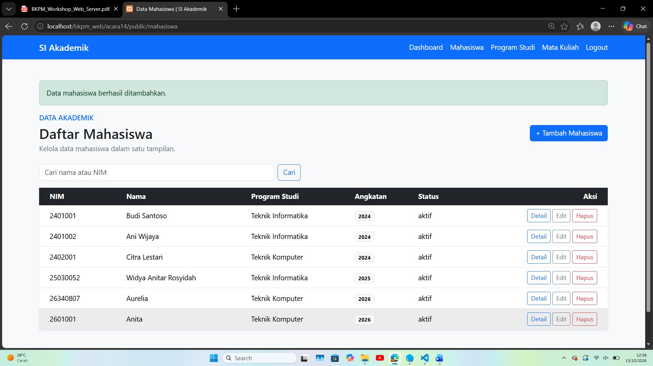

- Data mahasiswa berhasil diubah.

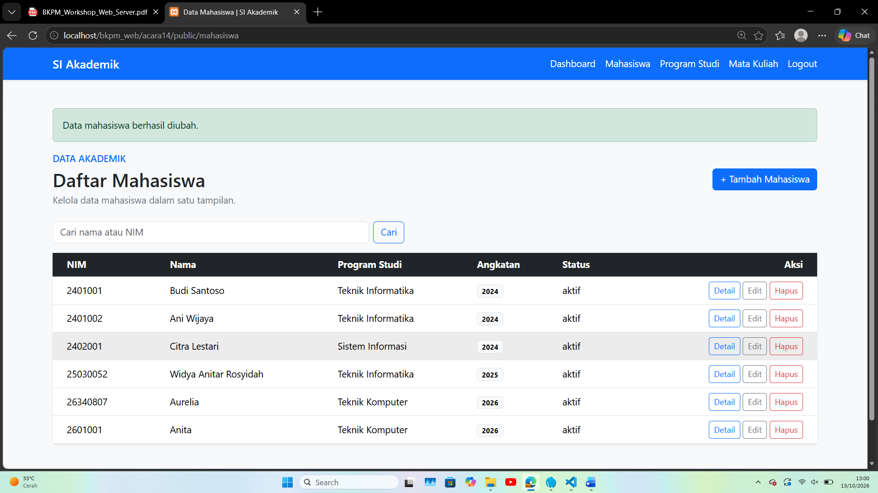

- Data mahasiswa berhasil dihapus.

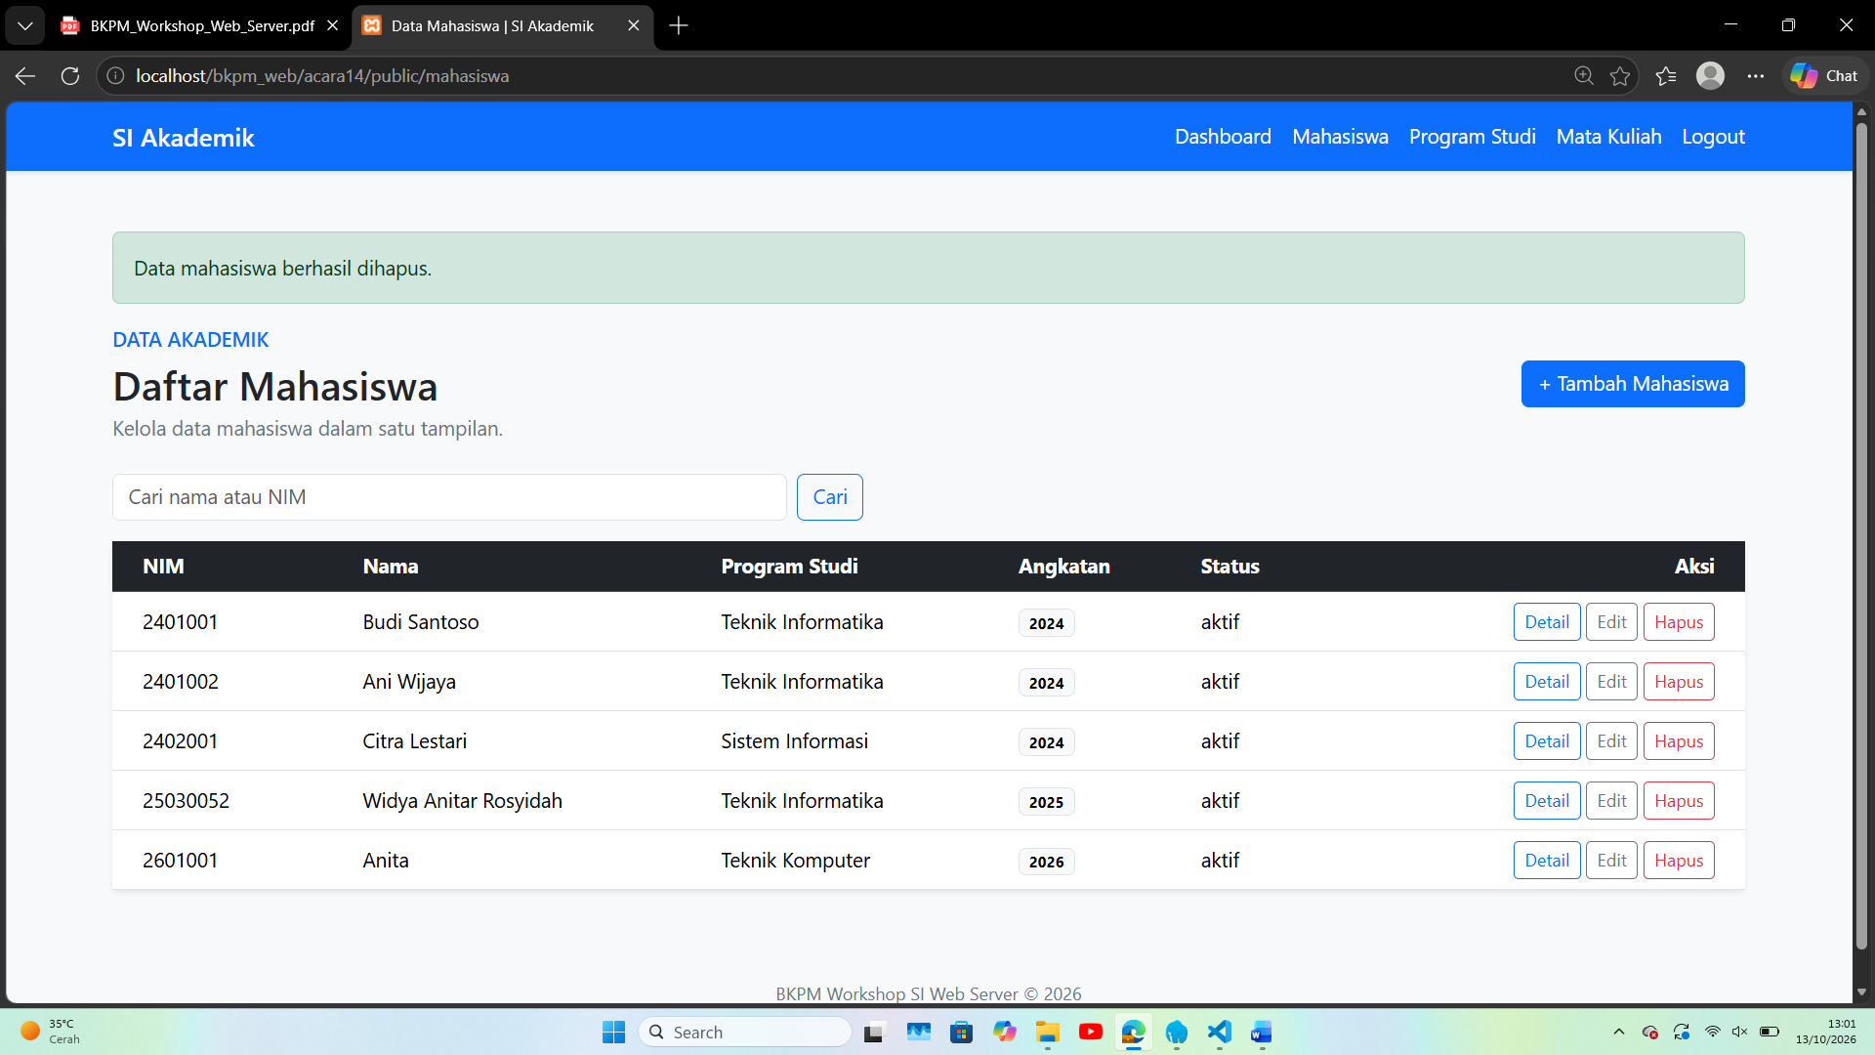
✕ Data gagal disimpan.
✕ NIM sudah terdaftar.
- Terapkan PRG
Setelah proses create, update, atau delete berhasil: POST → proses → redirect → GET
Urutannya adalah POST → proses → redirect → GET. Method redirect() mengirim header Location dan menjalankan exit, sehingga browser memuat halaman GET dan refresh tidak mengirim ulang POST. Rute-rute tersebut terdaftar di web.php.

